― PROJECT ANNOUNCEMENT ―
US 50 Resurfacing and widening between Las Animas & La Junta
PROJECT DETAILS
The Colorado Department of Transportation, in cooperation with A & S Construction, will begin work on US Highway 50 between Las Animas and La Junta. This resurfacing and widening project will take place from MP 387 to MP 397. Work will start on March 8 and continue through June.
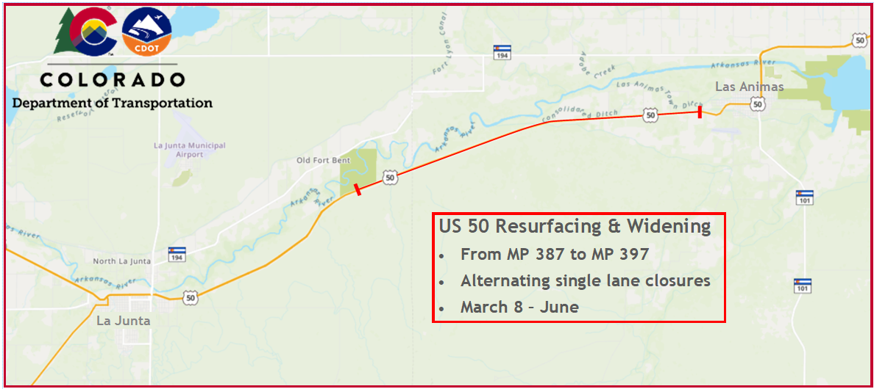
This project consists of roadway improvements including resurfacing, widening for passing lanes, guardrail replacement, sign replacement, roadway patching, and culvert installation. The passing lane will be added in the eastbound lane near MP 388 and be approximately 1500 feet long. This project will create smoother pavement and improved driving conditions, which in turn will improve safety along this corridor.
TRAFFIC IMPACTS
Beginning March 8, motorists will encounter road work on US 50. Traffic impacts include:
- Work will take place from 7 a.m. to 7 p.m. Monday through Thursday and 7 a.m. to 12 p.m. on Fridays.
- Speeds will be reduced to 45 mph in the work zone.
- During daytime activities, traffic flow will be reduced to alternating single lane traffic in multiple areas, with the use of flagger control.
- Traffic fines will be doubled in the work zone. Motorists should slow down as they approach the work zones, drive with caution, allow extra space between vehicles, and give themselves extra travel time.
PROJECT INFORMATION
For additional information about this project:
- Call the project information line at 719-299-5859
- Email the project team at: us50resurfacing@gmail.com
- Visit the project website at: https://www.codot.gov/projects/us50-las-animas-resurfacing

